1.4 I can create, select and use styles to keep the appearance of web pages consistent and make them easy to understand

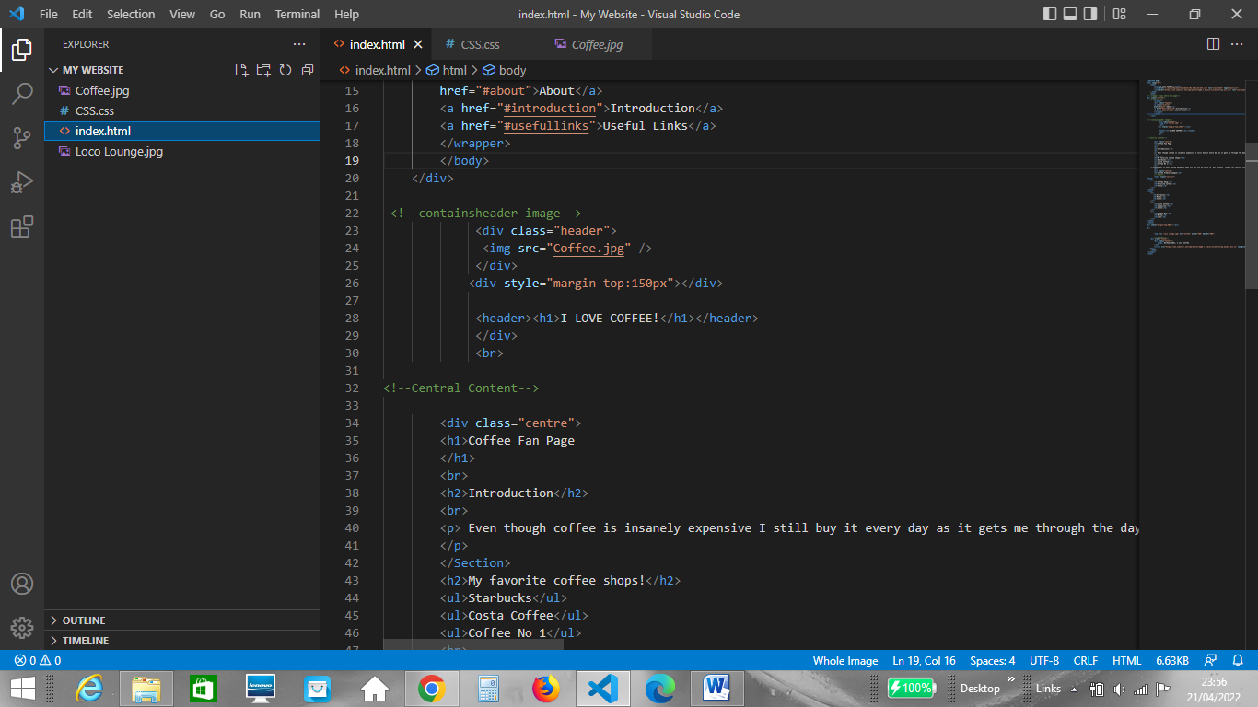When creating my website I wanted to ensure that it had a consistent overall theme. As the topic of my website was a coffee fan page, I choose to use a colour range of brown tones. I also wanted the text to be consistent. I used the html tags <H1> for titles and <H2> tags for subtitles.

I chose to style all my headings using CSS with the same colour and font to keep the overall look of the page consistent, example of the CSS I used below;

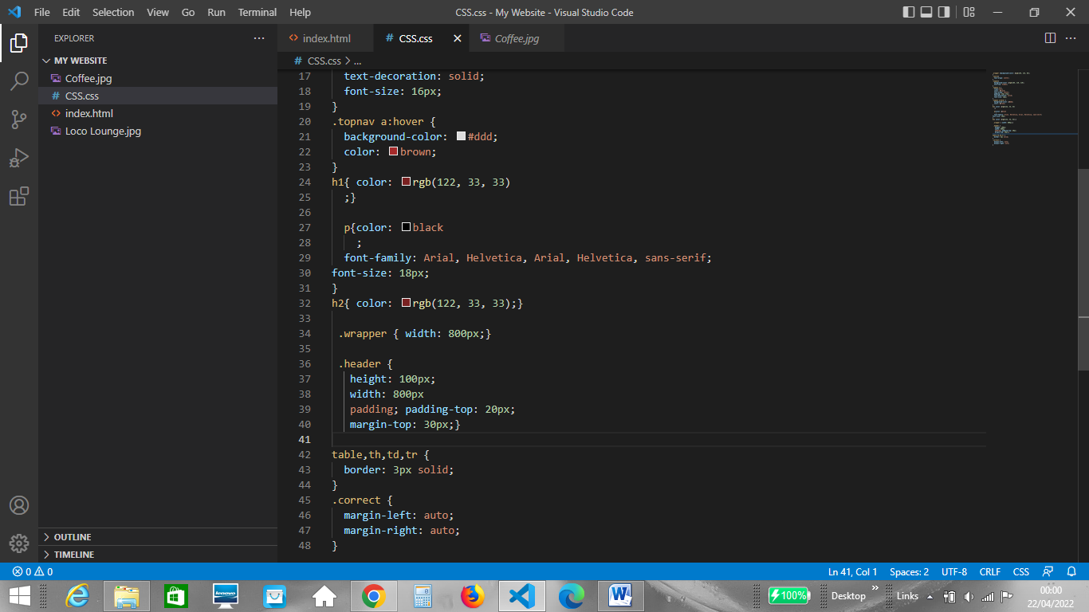

How the html and CSS look on the website;

